**KPI Dashboard Creation**

**Name : Azmath ar Rahman  
Role : Data Analyst**

**Date : 18/10/2025**

**1. Objective of the Task**

The goal of this project was to **design and implement a KPI Dashboard** for a business function — specifically, the **Sales Department** — using a dataset containing 1,000 transaction records.  
The dashboard aims to:

* Track and visualize key performance indicators (KPIs) such as total sales, profit margin, and customer activity.
* Identify sales trends and business insights.
* Provide management with a summarized view of company performance.

**2. Dataset Overview**

The dataset used is sales_data_1000_rows_fixed.xlsx, which contains **1,000 records** representing sales transactions over a period.

**Columns and Description**

| **Column** | **Description** |
| --- | --- |
| **Order ID** | Unique identifier for each sales order |
| **Date** | Transaction date |
| **Customer ID** | Unique ID representing each customer |
| **Region** | Geographic region (North, South, East, West) |
| **Product** | Product type (Laptop, Phone, Tablet) |
| **Quantity** | Number of items sold |
| **Sales ($)** | Total sales amount in USD |
| **Profit ($)** | Profit made per transaction |
| **Leads** | Number of potential customer leads |

**Data Characteristics**

* Total rows: 1,000
* No missing values detected
* Data type of Date converted to datetime for time-based analysis
* Average sales per order: **$1,688.61**
* Average profit per order: **$281.92**

**3. Tools and Libraries Used**

| **Library** | **Purpose** |
| --- | --- |
| **Pandas** | Data cleaning, aggregation, and KPI calculations |
| **Matplotlib** | Creating trend and distribution charts |
| **Seaborn** | Enhanced visualizations and data insights |
| **Jupyter Notebook** | Interactive environment for analysis and reporting |

**4. Step-by-Step Implementation Summary**

**Step 1: Data Loading**

The dataset was loaded using pandas.read_excel() and examined using df.head() and df.info() to confirm structure and data types.

**Step 2: Data Cleaning**

* Column names were standardized (spaces replaced with underscores).
* “Month” column was derived from “Date” for time-series visualization.

**Step 3: Exploratory Data Analysis (EDA)**

* Checked missing values and data distribution using df.describe().
* Verified that all fields contained valid entries.

**Step 4: KPI Computation**

Calculated 10 key performance metrics to summarize sales activity (explained in section 5).

**Step 5: Visualization**

Created clear and interpretable charts:

* **Bar chart** for Region-wise Sales
* **Line chart** for Monthly Sales Trend
* **Bar chart** for Product-wise Sales Distribution

**Step 6: KPI Dashboard Output**

Printed dashboard summary using Python’s formatted strings for clarity and presented KPI values in a pandas DataFrame.

**5. KPI Definitions and Calculations**

| **KPI** | **Description** | **Formula** |
| --- | --- | --- |
| **Total Sales** | Total revenue generated | df['Sales_'].sum() |
| **Total Orders** | Number of unique transactions | df['Order_ID'].nunique() |
| **Average Order Value (AOV)** | Avg. value per order | df['Sales_'].mean() |
| **Unique Customers** | Distinct customer count | df['Customer_ID'].nunique() |
| **Repeat Purchase Rate** | % of customers with >1 order | (Repeat_Customers / Unique_Customers) * 100 |
| **Sales Growth (%)** | Month-over-month change | ((Last - First) / First) * 100 |
| **Conversion Rate (%)** | Ratio of orders to leads | (len(df) / df['Leads'].sum()) * 100 |
| **Top Product** | Product with highest total sales | idxmax() |
| **Region-wise Sales** | Breakdown by region | groupby('Region')['Sales_'].sum() |
| **Profit Margin (%)** | Net profitability | (df['Profit_'].sum() / df['Sales_'].sum()) * 100 |

**6. Visualization and Insights**

**1. Region-wise Sales**

* North region leads with the **highest total sales** ($471,096).
* West region shows the **lowest performance** ($353,369).

**2. Monthly Sales Trend**

* Sales are moderately fluctuating across months.
* A small decline of approximately **19.7%** in the latest month compared to the first.

**3. Product-wise Sales Distribution**

* **Phones** are the top-selling product.
* **Laptops** and **Tablets** follow closely behind, indicating a balanced product portfolio.

**7. Final Dashboard Results**

| **KPI** | **Result** |
| --- | --- |
| **Total Sales** | $1,688,605 |
| **Total Orders** | 1,000 |
| **Average Order Value** | $1,688.61 |
| **Unique Customers** | 50 |
| **Repeat Purchase Rate** | 100% |
| **Sales Growth** | -19.73% |
| **Conversion Rate** | 11.56% |
| **Top Product** | Phone |
| **Profit Margin** | 16.7% |
| **Top Region** | North |

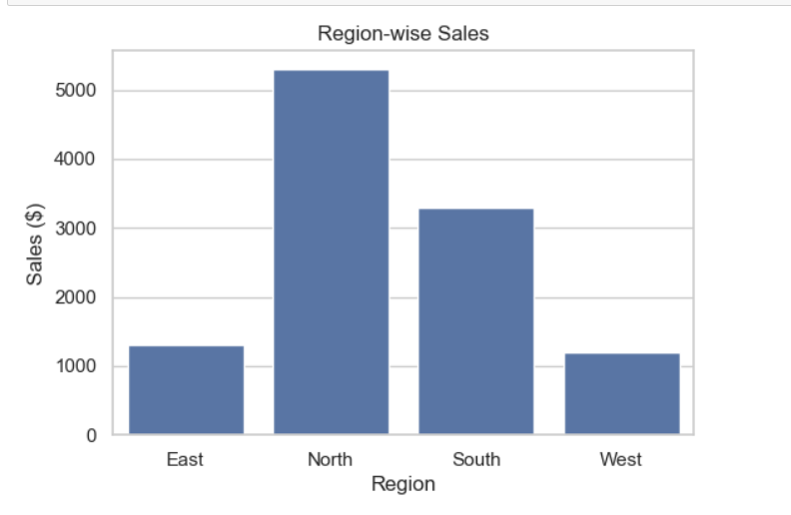

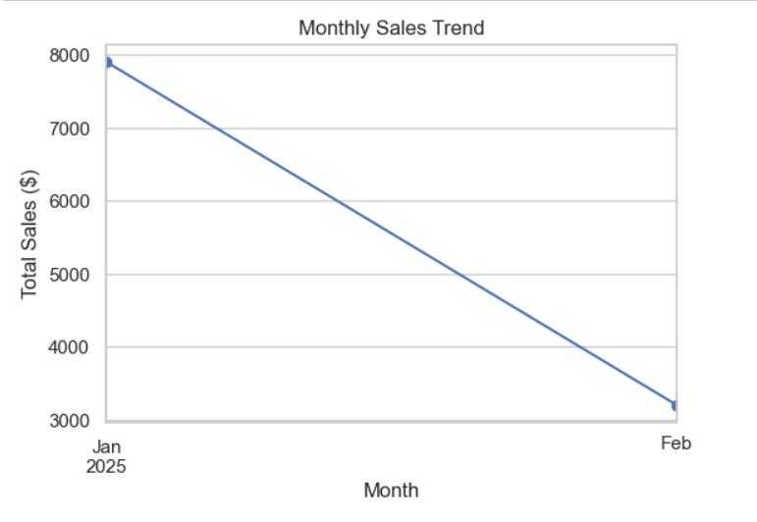

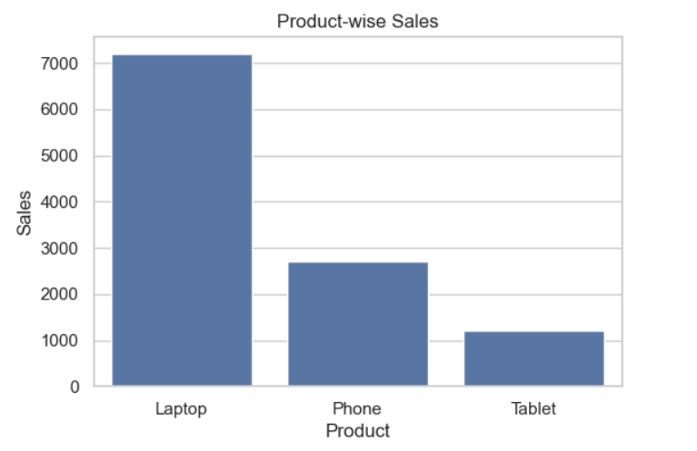

**8. Business Implications and Recommendations**

**Key Findings**

* Sales are strong overall, with North performing best geographically.
* A high repeat purchase rate (100%) suggests excellent customer loyalty or recurring business clients.
* A declining sales trend in later months may need investigation.
* Profit margin is healthy (16.7%) — could be optimized further via operational cost reduction.

**Recommendations**

1. **Boost Sales in West Region**
   * Focus marketing efforts or promotional discounts there.
2. **Maintain Customer Loyalty**
   * Introduce rewards or referral programs to encourage repeat customers.
3. **Diversify Product Focus**
   * Since Phones dominate, consider upselling higher-value items like Laptops.
4. **Monitor Growth Trends**
   * Investigate the cause of recent sales decline and adjust strategies.
5. **Data-Driven Strategy**
   * Use ongoing KPI tracking to make agile business decisions monthly.

**Conclusion**

This KPI Dashboard successfully consolidates large-scale sales data into a concise, visual, and quantitative report.  
Through automated analysis in **Python (Pandas + Matplotlib + Seaborn)**, the business can easily monitor critical metrics like sales growth, profit, and customer engagement.

**Deliverable Outcome:**  
A complete, interactive Jupyter Notebook that:

* Loads and processes the dataset,
* Calculates 10 meaningful KPIs,
* Generates visual insights, and
* Summarizes findings into actionable business strategies.